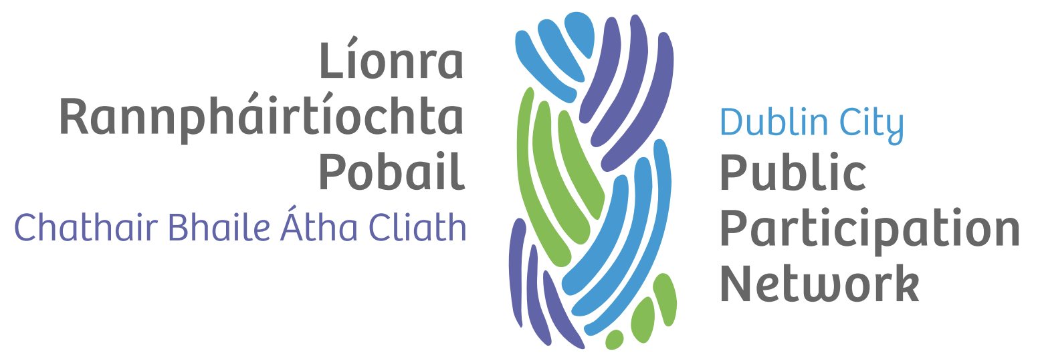

Plenary Standing Orders

Version history
Version | Date Adopted | Facilitator | Note
1.0 | September 2022 | TBC

Document controls
Action | Responsibility
Approval of document | Secretariat
Implementation | Secretariat and Staff
Review | Secretariat
Date of next review | September 2024

Introduction
The purpose of these standing orders is to ensure the orderly and effective conduct of Plenary meetings of the Dublin City Public Participation Network.

Agenda
- The agenda shall be prepared by the Secretariat. The order of business shall be:
  - Welcome address by PPN Secretariat Facilitator
  - Housekeeping duties, health and safety
  - Plenary standing orders
  - Minutes and matters arising
  - PPN activity report
  - Finance and budget update
  - Ratification of Linkage Group elections (if relevant)
  - Election to fill any Vacancies arising on the Secretariat and Local Community Development Committee (if relevant)
  - Items and motions submitted for discussion and decision.
  - Open Plenary session
  - Workshop / Information Session / Guest Speaker (if relevant)
  - Date of next meeting
  - Items that member organisations want included on the agenda shall be presented to the Secretariat at least 10 days prior to the date of the meeting. Similar items shall be taken as a composite item or motion as directed by Secretariat.

Facilitator
  - The Plenary meeting shall be facilitated by a member of the Secretariat or as set out in the constitution.

Minutes of the Plenary
  - The minutes of the Plenary shall be taken by a member of the Secretariat or PPN Staff.
  - The minutes shall include a record of those attending, actions arising, and decisions made.

Voting Rights and Decisions
- Only matters on the agenda shall be the business of the meeting.
- All decisions taken shall be in accordance with procedures set out in the constitution.
- Each named Dublin City PPN member organisation shall have one vote.
- Voting shall be by show of voting paddles or secret ballot where requested and in accordance with the constitution.
- Decisions shall be by simple majority.
- Voting for elections shall be by secret ballot.
- An objection in relation to the qualification of any voter must be raised prior to ballot being taken. Any such objection made in due time shall be referred to Facilitator of the meeting whose decision shall be final and conclusive.
- Two tellers shall be appointed by the facilitator to count votes. Anyone seeking to be elected to a position shall be disqualified from being appointed a teller.
- A clear record of voting result shall be signed by tellers and countersigned by Facilitator of the meeting.

Attendance at Plenaries
  - All named Dublin City PPN Organisations are entitled to attend the Plenary.
  - Dublin City PPN member organisations can send more than one representative to the Plenary. Only one of those representatives shall have voting rights.
  - The Secretariat may invite guest speakers to attend the Plenary.
  - The Secretariat may invite strategic partner organisations to attend the Plenary in an observer capacity.

Motions

Proposing of motions
Any motion proposed and seconded at the meeting becomes a resolution and shall take precedence in the discussion and shall be immediately placed before the meeting for discussion and resolution.

Voting on motions
A resolution is put to a vote when:
- The facilitator is of the view that such is the appropriate procedure at that point and such decision taken by facilitator shall be final; or
- A member proposes that the “Resolution be now put before the meeting” and such a proposal is seconded.
The resolution shall then be placed before the meeting for decision by simple majority – a ballot or show of voting paddles without any further debate.
Should a secret ballot be called for by three (3) or more members than a ballot shall precede with two tellers being appointed by the facilitator where the Facilitator is not available, through the election of a Standing Orders Committee for that meeting only. A demand for a secret ballot may be withdrawn by the person or persons who made the demand.
In the event of equality of votes the facilitator shall have a second or casting vote (should that person choose to use such a vote).
Where a resolution is not carried due to an equality of votes or is lost, the same resolution shall not be placed before the membership for a period of six (6) months.

Conduct at Plenary Meetings
  - Members shall observe accepted practice while taking part in the Plenary business, including:
- Be courteous and speak by addressing the Facilitator.
- Only address the meeting in order and as directed by the Facilitator.
- Always comply immediately with directions of the Facilitator.
- No cross talk or interruption of any speaker addressing the meeting.
- Follow the agenda and strive to reach effective decisions.
- Represent the views of your member organisation.
- Ensure mobile phones are in silent mode and avoid use.
  - Discrimination: All members attending the Plenary have the right to treated with dignity and respect regardless of their race, colour, ethnic or national origins, nationality, gender, age, sexuality, religion or any other matter which causes people to be treated with injustice.

Adjournment of Meeting
Where a proposal is made by a member to adjourn the meeting and such proposal is seconded then that proposal shall be taken forthwith without further debate and placed before the meeting for resolution by simple majority.
Where such a proposal is carried, the meeting shall by simple majority decide when (date, time and place) the meeting as adjourned is reconvened.

Suspension of Standing Orders
Standing orders as regards any meeting may be suspended by simple majority of members present to address urgent item of business.

