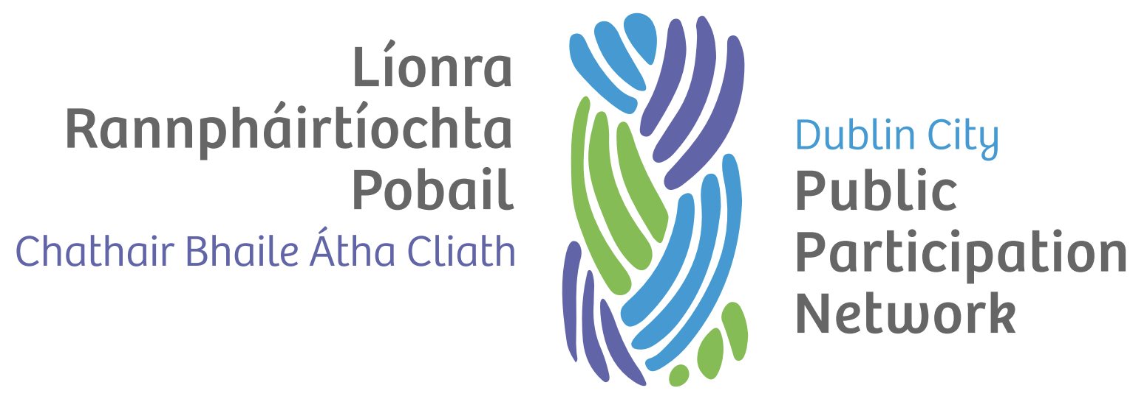

Code of Conduct

Version history
Version | Date Adopted | Facilitator | Note
1.0 | September 2022 | TBC

Document controls
Action | Responsibility
Approval of document | Secretariat
Implementation | Secretariat and Staff
Review | Secretariat
Date of next review | September 2024

Introduction
This Code of Conduct applies to all PPN members in their participation in PPN activity. All PPN members have a duty of care and responsibility to act in the best interests of the PPN complying with this Code of Conduct and the provisions of the Constitution.

Organisational Values
All Members commit to and promise to comply with the fundamental values that underpin all the activities of PPN.

Accountability
As a member everything you do and every interaction you are involved in shall be able to stand the test of scrutiny by members of the public, the media, members, beneficiaries, stakeholders, and the local authority.

Integrity and Honesty
These shall be the hallmarks of all conduct within and on behalf of the PPN particularly when dealing with fellow members, colleagues, external individuals, and agencies.

Transparency
PPN Members shall promote an atmosphere of openness throughout the PPN to promote confidence to members of the public, elected representatives, beneficiaries, and the local authority and to promote strategic and operational effectiveness.

Governance
PPN Members shall always support the ethos and values of PPN and ensure compliance with good governance and shall:
- Commit to supporting and advocating compliance with good governance within the sector.
- Participate in appropriate induction, training, and development programmes.
- Support the PPN staff in their executive function and the PPN Facilitator in their leadership role.

Conflicts of Interest
PPN Members shall declare any potential Conflict of Interest and/or Conflict of Loyalty or any such circumstance as may be viewed by others as conflicting as soon as it arises.
PPN members shall abide by decisions of the Secretariat and comply with any requirements it requires regarding potential conflicts of interest or loyalty.

Guardian of the PPN’s reputation
Members shall uphold the reputation of the PPN. This includes:
- Not speaking as a member to the media or any public forum without the prior knowledge and approval of the Facilitator of the Secretariat.
- Ensuring that any comments made shall reflect current policy even if they do not agree with them.
- Respecting individual confidentiality.
- Taking an active interest in the PPN’s public image.
- Supporting the PPN’s vision, values, principles and aims and actively promote these.
- Complying with PPN’s policy and procedure.
- Seeking to maintain and promote integrity, good governance, effectiveness, and efficiency for the delivery of the aims of PPN.
- Not breaking the law or acting against any regulation in force that would bring the PPN into disrepute.

Personal Gain
Individuals shall:
- Not personally gain from their role as a member nor permit others to do so because of actions of negligence.
- Not accept gifts or hospitality without the consent of the Facilitator.
- Document expenses and seek reimbursement according to the agreed procedure.
- Use PPN resources responsibly, when authorised in accordance with procedure.

Breaching this Code:
A breach of this code may result in that person’s removal from the PPN or any of its constituent levels – Linkage Groups, Secretariat, or any representative role.

