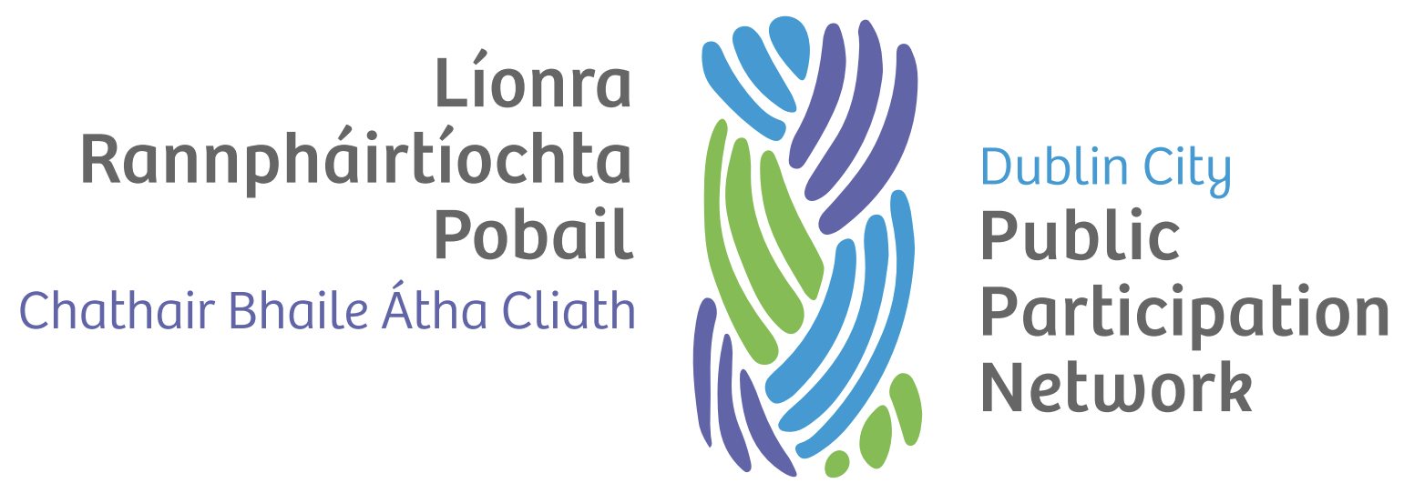

Expenses Policy

Version history
Version | Date Adopted | Facilitator | Note
1.0 | September 2022 | TBC

Document controls
Action | Responsibility
Approval of document | Secretariat
Implementation | Secretariat and Staff
Review | Secretariat
Date of next review | September 2024

Introduction
In general, any reasonable expenses arising for a Dublin City Public Participation Network (PPN) Representative on official business shall be met by Dublin City PPN.

Definitions
For the purposes of this policy, a PPN Representative is one of the following:
- Member of the Secretariat,
- PPN member elected/nominated to represent the PPN on a board or committee,
- PPN member who is representing the PPN at an event, conference or function, or
- A PPN member who is availing of access supports to enable participation in the PPN.

Key principles
The following key principles underpin this policy:
- PPN Representatives should be properly compensated for out-of-pocket expenses when contributing their time and expertise to any activities associated with representing the PPN in an official and organised capacity.
- The process of claiming for the reimbursement of expenses should be as straightforward as possible while following procedures that allow the PPN to properly account for payments made.
- Support shall be provided to PPN Representatives who require help in submitting claims for the reimbursement of expenses
- Payment shall only be approved for meetings for which a report has been received by a PPN Representative, where required.

Travel
- A mileage allowance of 51 cent per kilometre shall be paid for travelling to and from meetings by personal vehicle.
- Where Public Transport is used, payment at the value of the cost of the journey is paid.

Subsistence
- The cost of receipted food or drink that was bought on the day of an official engagement can be reimbursed if:
  - When the total time involved has been five hours or more; or
  - If no food or drink was provided at the meeting, training etc.
- Alternatively, a subsistence payment of up to €16.29 may be claimed.

Conferences and overnight engagements
The PPN may reimburse the cost of tickets or registrations fees to relevant conferences, training and events a PPN Representative may attend with prior approval from the Secretariat.

Annual PPN Conference
The PPN aims to maximise participation at the annual PPN conference while controlling costs in the context of the PPN budget. Accommodation for the annual conference will be sourced and paid for directly by the PPN. Travel to the annual conference will be by public transport, the cost of which shall be reimbursed. Alternative arrangements can be made in exceptional circumstances and with prior approval from the Secretariat.

Administration
- All claims are subject to the available budget being available.
- Claims are to be made at minimum every six (6) months, in June and December each calendar year, otherwise expenses are deemed forfeited.
- All claims shall be reimbursed by electronic transfer – all PPN Representatives in receipt of expenses are required to provide bank account details.
- Claims are to be made on the official Travel and Subsistence Claims Form.

