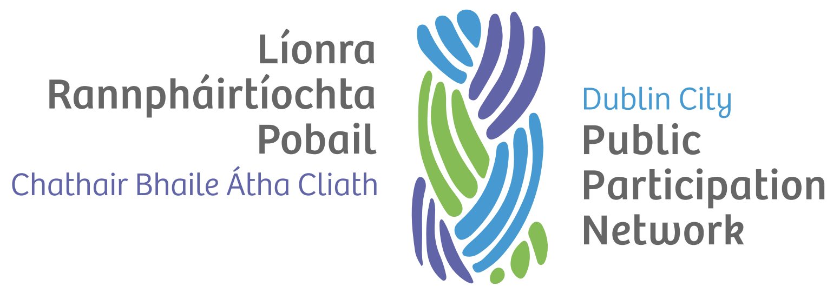

Supervisory Working Group Terms of Reference

Version history
Version | Date Adopted | Named approvers | Note
1.0 | September 2022 | TBC

Document controls
Action | Responsibility
Approval of document | Secretariat, Dublin City Volunteer Centre, Dublin City Council
Implementation | Secretariat, Dublin City Volunteer Centre, Dublin City Council
Review | Secretariat, Dublin City Volunteer Centre, Dublin City Council
Date of next review | September 2024

Introduction
The Supervisory Working Group consisting of representatives of Dublin City Volunteer Centre, Dublin City Council and Dublin City PPN shall cooperate in carrying out their responsibilities in monitoring and evaluating the PPN Work Plan, financing, and resourcing.

Members
The working group comprises of:
- A representative from Dublin City Volunteer Centre.
- A representative from Dublin City Council.
- A representative from Cork City PPN Secretariat.
- The PPN Resource Worker.

Meetings
The Supervisory Working Group shall meet at least quarterly. Generally, this shall be in February, May, September, and December each year.

Agenda
A typical meeting agenda shall be:
- Noting of any DRCD communications.
- Progress on PPN Work Plan.
- Report on PPN Finances.
- Any operational issues.
- National PPN Secretariat Network Update
- National PPN Workers Network Update
- Review of Memorandum of Understanding and Service Level Agreement (where relevant)
- HR Subgroup (PPN Resource Worker excused)

Convenor
The working group shall be convened and chaired by Dublin City Council. Where meetings are not scheduled by Dublin City Council, they shall be scheduled by Dublin City Volunteer Centre.

