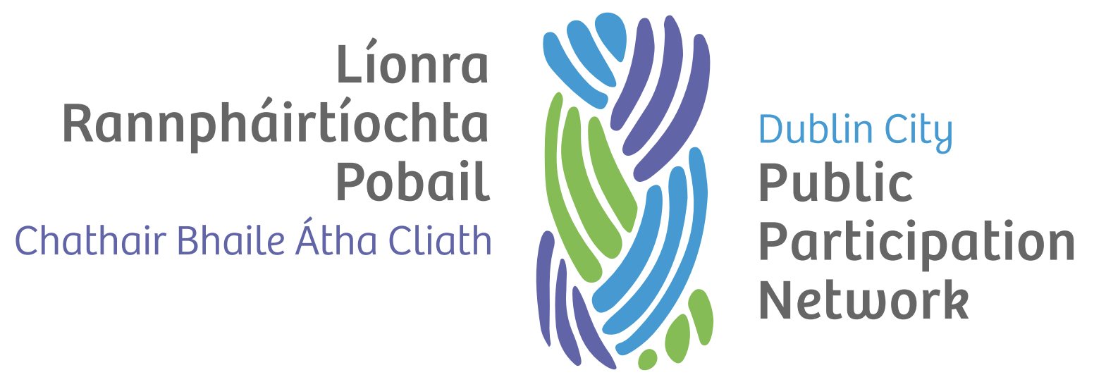

Complaints Procedure

Version history
Version | Date Adopted | Facilitator | Note
1.0 | XX 2021 | TBC
2.0 | September 2022 | TBC

Document controls
Action | Responsibility
Approval of document | Secretariat
Implementation | Secretariat and Staff
Review | Secretariat
Date of next review | September 2024

Introduction
Dublin City Public Participation Network (Dublin City PPN) is committed to dealing effectively with any complaints one might have about our service. If we got something wrong, we will apologise and where possible we will try to put things right. We also aim to learn from our mistakes and use the information we gain to improve our services.

When to use this complaints procedure
When one makes a complaint to us, we will usually respond in the way we explain below. Sometimes, one might be concerned about matters that are not decided by us (e.g. issues relating to ones grant application or appeals to the Local Authority) and we will then advise as to the best way of making ones concerns known.

Informal resolution
If possible, we believe it is best to deal with things as soon as possible and in the easiest and most direct way. If one has a complaint, raise it directly with the person one is dealing with. He or she will try to resolve it there and then.
However, they may need time to look into it, which may take up to five (5) working days. If there are any lessons to learn from addressing this complaint, we will bring them to the Secretariat and the Plenary. If the person one had dealings with is unwilling or unable to resolve the matter, they will explain why and may quest for the complaint to be formally investigated.

How to complain formally
Complaints may be made in any of the following ways:
- One might request a copy of our complaint form from the person with whom one is already in contact.
- One might get in touch with Dublin City PPN Resource Worker on telephone ______ when making a complaint by telephone.
- One might complete the complaint form on our website at www.dublincityppn.ie/complaintform
- One might e-mail us at complaints@dublincityppn.ie
- One might write a letter to us at the following address: Resource Worker, Dublin City PPN,

What should you include in your complaint
- State name of complainant, address and telephone number (and email, if applicable) and whether you are acting on behalf of someone else.
- Briefly describe what complaint is about stating relevant dates and times, if applicable.
- Be specific, list the concerns giving priority to those of most important concern.
- Be clear about the desired outcome from this process (for example an apology, explanation, etc.)
- State the preferred method of communication i.e. telephone, email or letter.

It will assist the PPN Resource Worker if extra information and/or copies of relevant documents included with the complaint.

Dealing with your complaint
We will formally acknowledge the complaint within a maximum of five (5) working days and confirm with complainant how we intend to deal with it. We will request the claimant to tell us how you would like us to communicate with them and establish whether any reasonable accommodations are required, for example, if one has language difficulties.
We will deal with complaints in an open and honest way. If one is making a complaint on behalf of somebody else, we will need their agreement for representative to act on their behalf.

Investigation
Complainant will be informed as to who we have asked to investigate ones complaint. If the complaint is straightforward, we will request Dublin City PPN staff member to investigate the matter and revert to complainant.
If the complaint is of a serious nature, we may request an individual from outside the PPN to investigate. We will confirm with the complainant our understanding of the complaint and ask for confirmation that we have the correct understanding of the issue. We will request the complainant to articulate their desired outcome from the process. The person reviewing the complaint will need to see the files we hold relevant to the complaint. If this is not the desire of the complainant we must be informed. If there is a simple solution, we may request resolution if all parties are in agreement. We will aim to resolve concerns as quickly as possible and expect to deal with the vast majority within 30 working days.
If the complaint is more complex we will:
- inform complainant within this time why we believe it may take longer to investigate.
- inform complainant long we expect it to take,
- provide complainant with regular updates fortnightly on any progress made.
The person appointed to investigate the matter will aim first to establish the facts. The extent of this investigation will depend on how complex and how serious the issues raised are. In complex cases, we will develop an investigation plan. In some instances, we may request to meet complainant to discuss the matter. Occasionally, we might suggest mediation or another method to try to resolve disputes. When investigating the matter, we will look at relevant evidence. This may include files, notes of conversations, letters, emails or whatever may be relevant to the complaint. If necessary, we will talk to the staff or others involved and look at our policies and any guidance.

Outcome
If, we formally investigate a complaint, we will share the findings with the complainant what we have found in keeping with the preferred form of communication. This could be by letter or email, for example. If necessary, we will produce a more in-depth report. We will explain how and why we arrived at our conclusions.
If we find that we got it wrong, we will tell you what and why it happened. If we find there is a fault in our systems or the way we do things, we will tell you what it is and how we plan to change things to stop it happening again. If we got it wrong, we will always apologise.

Putting things right
If we did not do something well, we will aim to put it right. If complainant has lost out as a result of a mistake on our part we will try to put the complainant back in the position they would have been in if we had got it right.

Learning Lessons
We take complaints seriously and try to learn from any mistakes made on our part. Our Secretariat considers a summary of all complaints on a regular basis as well as details of any serious complaints. Where there is a need for change, we will develop an action plan setting out what we will do, who will do it and when we plan to do it by. We will let you know when changes we have promised have been made.

Appeal
If we formally investigate your complaint and you are not satisfied with the outcome you may request an optional local appeal which will be dealt with by persons not involved in the original handling of your complaint.

Department of Rural and Community Development
If we do not succeed in resolving your complaint, you may complain to the Department of Rural and Community Development (DRCD). The DRCD is the Government Department responsible for the oversight of Public Participation Networks and can look into your complaint if you believe that you personally, or the person on whose behalf you are complaining have been treated unfairly or received a bad service through some failure on our part.
The DRCD expects you to bring your complaint to our attention first and to give us a chance to put things right. You can contact the DRCD by:
- telephone: 076 106 4900
- email: ppn@drcd.gov.ie
- writing to: Department of Rural and Community Development, Trinity Point, 10-11 South Leinster Street, Dublin 2, D02 EF85

For those who might need assistance in making a complaint
Staff of Dublin City PPN will aim to assist the complaint in the complaints procedure. Should one requires additional assistance, we will put one in touch with someone to assist. Complainant may request an individual to assist them with the matter.

What we expect from complainant
In times of trouble or distress, individuals may act out of character. There may have been upsetting or distressing circumstances leading up to a complaint. We do not view behaviour as unacceptable just because someone is forceful or determined. We believe that all complainants have the right to be heard, understood and respected.
However, we also consider that our staff and volunteers have the same rights. We, therefore, expect you to be polite and courteous in ones dealings with us. We will not tolerate aggressive or abusive behaviour, unreasonable demands or unreasonable persistence.

Complaints Form: On ones own behalf

Complainant details
Name
Address
Email
Telephone
Please confirm preferred method of communication by ticking the appropriate field:
Telephone |  | Email |  |  | In Writing
Reasonable accommodations: if the typical way of dealing with complaints is difficult, please inform us so we might look for a more appropriate method of engagement.
The complaint
Please describe the matter in which one is making a complaint. Be specific and prioritise matter in order of importance.
Describe how the complainant has suffered or has been affected by the matter.
What should be done to put things right?
Have you already put ones concern to the person responsible? If so, please give brief details of how and when.
If you have any documents to support this concern/complaint, please attach with this form.
Signature of complainant
Date
Upon completion of this form, please return it to: Dublin City PPN Resource Worker

Complaints Form: On behalf of someone else
Complainant details
Name
Address
Email
Telephone
Please confirm preferred method of communication by ticking the appropriate field:
Telephone |  | Email |  |  | In Writing
Reasonable accommodations: if the typical way of dealing with complaints is difficult, please inform us so we might look for a more appropriate method of engagement.
What is the relationship between person completing form and the complainant?
Why is representation been made on behalf of the complainant?

The complaint
Please describe the matter in which one is making a complaint. Be specific and prioritise matter in order of importance.
Describe how the complainant has suffered or has been affected by the matter.
What should be done to put things right?
Were these concerns raised with the person responsible? If so, please give brief details of how and when.
If you have any documents to support this concern/complaint, please attach with this form.
Signature of complainant
Date
Signature of representative
Date
Upon completion of this form, please return it to: Dublin City PPN Resource Worker

