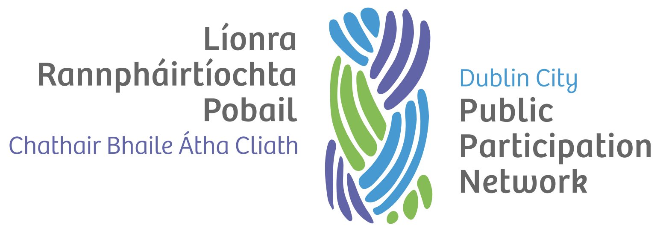

Representatives Charter

Version history
Version | Date Adopted | Facilitator | Note
1.0 | September 2022 | TBC

Document controls
Action | Responsibility
Approval of document | Secretariat
Implementation | Secretariat, Staff and PPN Representatives
Review | Secretariat
Date of next review | September 2024

Introduction
This charter outlines the role, responsibilities and rights of PPN Representatives.

Role of a PPN Representative
A PPN Representative shall:
- Attend and participate fully in meetings of their Linkage Group and Board or Committee, including any subgroups to which they may be appointed.
- Bring forward the issues of the Linkage Group to the Board or Committee for their consideration, including placing items on the Agenda.
- Work openly and collaboratively with the Linkage Group to identify issues, research, policy proposals etc.
- Communicate regularly (at least as frequently as meetings are held) with the Linkage Group on matters such as:
  - Dates of Board or Committee meetings.
  - Agendas for Board or Committee meetings.
  - Reports and Feedback from Board or Committee meetings.
  - Items which require their input or are of interest.
- Network and work strategically with other Board or Committee members for the benefit of the Linkage Group and of PPN, including being able to compromise while retaining the core objective.
- Attend and participate fully in the Plenary, Representatives Forum and Representative Training.

Responsibilities of the PPN Representative
A PPN Representative shall:
- Assist in the organisation of and preparation of Linkage Group Meetings and effective two-way communications with Linkage Group members (with the support of the resource worker).
- Prepare thoroughly for, attend and participate actively in Linkage Group and Board or Committee.
- Participate in meetings solely on behalf of PPN, leaving any personal, business or political interests outside.
- Work openly and collaboratively with all Linkage Group members to identify issues, research, policy proposals etc., respecting the diversity of views expressed.
- Put forward opinions and views of Linkage Group to The Board or Committee and feedback clearly using plain English to the Linkage Group.
- Attend relevant training or networking events organised by PPN or the Committee.
- Be open and honest in dealings with all stakeholders.

Rights of the PPN Representative
A PPN Representative shall:
- Have active engagement from the Secretariat, Linkage Group and Plenary, including timely responses to issues.
- Be heard and respected at both the Linkage Group and Board or Committee, with an appreciation that they are a volunteer.
- Be supported by both Linkage Group and Board or Committee members.
- Receive relevant training to enable them to participate effectively on the Board or Committee.
- Receive expenses for attending Board or Committee meetings including any subgroups and relevant training.
- Receive an induction pack for the Board or Committee on taking up appointment to include:
  - Terms of reference.
  - Standing orders and procedures.
  - Meeting schedules, locations and times.
  - Contact details for all Board or Committee members.
  - Access to technical support where required.
- Receive as much notice as possible of meetings and associated documentation in advance as permitted by the relevant standing orders of the committee or board.
- Have meetings conducted in a way that facilitates participation, open discussion and transparent decision making.

