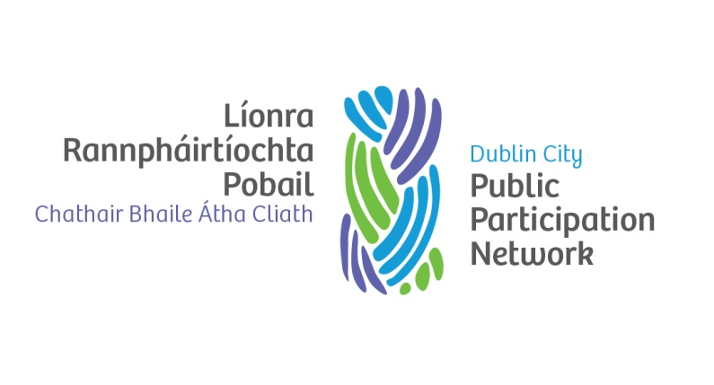
DUBLIN CITY PPN NOMINATION FORM
ARTS, CULTURE AND RECREATION
STRATEGIC POLICY COMMITTEE
The following areas fall under the responsibility of the Arts, Culture and Recreation Strategic Policy Committee:

Events & Festivals; Libraries; Archives; Museums; Galleries; Arts; Parks and Open Spaces; Casual trading; Control of Horses & Dogs; School Meals; Sports and Recreation Centres; Sports Development;

Policy issues currently being discussed at the meeting are:

Proposed new City Library at Parnell Square; Review of Casual Trading (Control and designation) Bye Laws; Sport Health and Wellbeing Partnership; City Development Plan

There are a minimum of five meetings a year, held every two months on the 2nd Monday of the month at 9.30 a.m. Generally there are no meetings in July and August.

Name of Organisation_______________________________________________________
Please tick PPN pillar you are registered under (if not known please leave blank):
Environment Pillar Community & Voluntary Pillar

Social Inclusion Pillar

We the undersigned
- Confirm that the nominee _______________________________________(PRINT Nominee Name) is a member of the above organisation.
- Are satisfied that this nominee meets the PPN criteria and requirements for committee representation (Please see criteria overleaf).
- Have completed the candidate form outlining how the nominee meets the requirements.

Signed (Proposer): ___________________________________ Date: _______________

Signed(Nominee): ____________________________________ Date: _______________

Please supply contact details for the nominee:
E-mail: ___________________________________ Mobile Number: _________________

DUBLIN CITY PPN CANDIDATE FORM
ARTS, CULTURE AND RECREATION STRATEGIC POLICY COMMITTEE

Candidate Name: __________________________________________________________

Member Organisation: _______________________________________________________
Please outline your experience and any qualities that you consider beneficial to the role of
representing the entire PPN. Please see criteria attached.

__________________________________________________________________________
__________________________________________________________________________
__________________________________________________________________________
__________________________________________________________________________
__________________________________________________________________________
__________________________________________________________________________
__________________________________________________________________________
__________________________________________________________________________
__________________________________________________________________________
__________________________________________________________________________
__________________________________________________________________________
__________________________________________________________________________
__________________________________________________________________________
__________________________________________________________________________
__________________________________________________________________________
__________________________________________________________________________
__________________________________________________________________________
__________________________________________________________________________
__________________________________________________________________________

N.B Candidate Form must be completed to ensure valid nomination. Information provided on the Candidate Form will be circulated to ALL MEMBERS of the PPN
PLEASE RETURN BY MONDAY 2nd OCTOBER 2017

Criteria for qualification for Arts, Culture & Recreation Strategic Policy Committee
Representing the PPN on the Strategic Policy Committees (SPCs) is an important task. It is the task of the SPC’s, as committees of the council, to advise and assist the council in its work. The SPC system is intended to give councillors and sectoral interests an opportunity for full involvement in the policy-making process from the early stages. Therefore, if the SPC system operates satisfactorily, much of the preliminary and background work, discussion and recommendation should be completed at SPC level for final consideration and ratification by the council.
In order to ensure that representation is informed and based on knowledge of the policy area and on commitment to the PPN, the following criteria for PPN representation will apply:
- An awareness of general policy in the area you are seeking to represent on
- The ability of the nominee to effectively represent the views of the entire PPN linkage group. They are not representing their own organisation.
- A knowledge of the relevant areas and plenary decisions and a commitment to policy
development where necessary.
- A commitment to attending all meetings of the SPC
- Support new representatives should the need arise
- A commitment to convene, attend and report back to the linkage group relevant to the committee you are sitting on
- A commitment to issuing a report on each meeting for publication by the PPN Resource Worker
It is desirable that sectoral nominees would retain membership of the SPC for the life of the Council. It is open to each nominating sector to deselect its nominee, if felt necessary, and to notify the Council accordingly whereupon the person would cease to be a member. In such cases the relevant sector will nominate a new representative

In addition to the above, the following generic requirements must be met:
- Elected representatives of Local Authorities cannot be nominated through this process.
- If anyone nominated through this process subsequently decides to enter electoral
politics he/she must immediately resign their PPN representative role and the relevant
nominating PPN Pillar or Linkage Group will choose a replacement.
- A person who has been an elected representative of any level of Government (local or
national) should not be chosen to represent PPN in any representative role for one year
after completing their term of office.
- All PPN representatives must meet the criteria laid down by the member organisations
that they represent on the PPN.
Specifically the role of the representative is to:
- Bring issues of relevance from the linkage group that chose them to the policy making arena.
- Give feedback to their Linkage Group, Electoral Pillar and/or Plenary as appropriate on
the outcomes of the policy meetings and the issues being raised.

