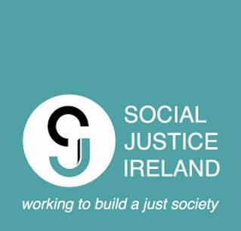

# Help us understand how to make PPNs even more effective!

**Take part in a focus group aimed at understanding the strengths and weaknesses of Public Participation Networks and how they can be improved**

As part of the Irish Research Council Funded project ***Enhancing Participation in Local Democracy: Opportunities and Challenges via Public Participation Networks*** (NF/2023/1324)***,*** researchers from UCD’s School of Social Policy, Social Work and Social Justice want to talk to people with experience of working with and in Public Participation Networks. We want to understand how PPNs are perceived of, and engaged with, by civil society, policymakers and politicians. Our aim is to explore how to make PPNs more effective vehicles for driving local and regional change.

A recent report from Social Justice Ireland identified differences in how different groups participated within PPNs and how this affected local policymaking. SJI recommended further research in this area, which is the aim of this project. We want to talk to those with first-hand experience and knowledge of the operation of PPNs to understand where PPNs work well and, importantly, where they can improve, particularly from the perspective of the groups engaged with PPNs.

The focus group will take no longer than 90 minutes and will likely involve between 6-8 participants and 1 or 2 researchers discussing topics as a group. The focus group may be either in person or online.

Our aim is to use the research findings to develop a series of recommendations to improve the operation of PPNs, and to improve pathways from deliberations into policy. Your input, as those with experiences of working with/in PPNs, is essential to this.

**If you would like to participate, come along to one of our online focus group sessions on Thursday, May 1st. There will be sessions at 12.30pm and 7pm via Zoom.**

If you have any questions at all, please do not hesitate to contact the Primary Investigator, Dr. Matthew Donoghue ([matthew.donoghue@ucd.ie](mailto:matthew.donoghue@ucd.ie)) or the Research Assistant, Khalil Moran ([bernard.moran@ucdconnect.ie](mailto:bernard.moran@ucdconnect.ie))