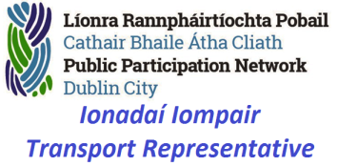

Transport SPC representative

Report on

Draft Dublin city transport Plan 2023

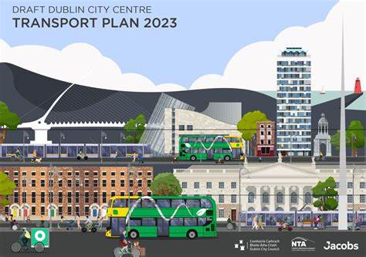

**Contents**

1.0 Background 3

2.0 Main Areas 5

2.1Planning and design 5

2.2 Footpaths 6

2.3 Cycle Lanes 8

2.4 Crossings 10

2.5 Parking 11

3.0 Proposed areas of change 12

3.1 College Green 12

3.2 Parliament Street 14

3.3 Batchelors walk 16

3.4 South Quays 18

3.5 Liberty place 19

3.6 Custom house quay 21

3.7 Gardiner street 23

3.8 Pearse Street 25

3.9 Lincoln place 27

3.10 Christchurch place 29

4.0 Information and Consultation 31

5.0 Conclusion 31

**The PPN would like to thank the following for their assistance:**

**Members of the Disability Thematic Group**

# Background

**This report has been designed to explain the changes that are proposed and to show the different impacts on the various modes of travel and transport used in the city centre area.**

**The plan itself is a part of the NTAs transport strategy for the greater Dublin area 2022 to 2042 as well as Dublin city councils own city development plan.**

**Since Covid occurred the council realised that more space was required for pedestrians and cyclists in the city centre.**

**However the council also had to meet new emission targets of a 50 percent reduction in emissions by 2030.**

**Originally the council planned to make changes within the canal area of the city but changed the plan to a more core city centre area that reached from mountjoy square to Stephens green and from Smithfield to custom house quay.**

**The city council surveys traffic flows across the city and as part of this plan has set out how it would like to see a change of use of transport across the city centre.**

**Using 2019s figures people crossed the city by the following methods**

**11 percent walked**

**6 percent cycled**

**54 percent used public transport**

**29 percent were cars taxis and goods vehicles**

**By 2028 the council hopes to change that to**

**13 percent walking**

**13 percent cycling**

**57 percent public transport**

**17 percent car taxi and goods**

**In looking at these figures the council hopes to mainly have a shift from car and taxi to cycling by 7 percent with a 2 percent rise to public transport and walking only.**

**This 12 percent decrease would mainly be down to cars been diverted away from city centre streets**

**It must be noted that the council surveys had noticed that 60 percent of cars travelling though the city centre area were going to destinations outside of the area and had started also from outside of the area so it is this group of cars that the plans mainly target to remove.**

**Another aspect of the plan is to make it easier to construct the major upcoming city projects like the metro as traffic will already be diverted away so the metro work should have less of an impact on travel.**

**City centre changes are not a new thing street changes have happened since Grafton Street was first pedestrianised right up to the recent creation of the traffic free Capel Street.**

**A lot of people are also working remotely now so there is less traffic in general accessing the city centre then before so if improvements can be done to improve footpaths bus routes and cycle routes now is the ideal time to do it.**

# 2.0 Main Areas

**In looking at the new plan the main things noted have been in design and modal change so all the items that affect change have been sorted into their respective sections**

**In general the PPN is very supportive of the plan to improve footpaths and cycle lanes in the city centre and realises that if it is done correctly that it will benefit all members of society.**

**The plans are very good in theory and if they work as stated then it should be easier for residents to walk cycle and commute safely within the Dublin City area.**

## 2.1Planning and design

**In designing a quality cycle lane planners have difficult choices including how to deal with junctions and pedestrian pinch points**

**According to Dublin City Council all Transport planning should be done with the pedestrian at the top followed by the cyclist and then public transport.**

**In looking at design the NTA and city council needs to use their own guidelines for cycle lanes for best cycle practices and also the relevant design documents for city living. The planners should also take into account any public realm works that are proposed in the areas and also to the needs of the area as well as the feeder cycle routes into each area.**

**I have broken down the design into 3 key areas and have set out the major recommendations that the various groups within the PPN have looked for be they groups representing young or older residents and also Disability groups as well as those who represent residents living and working in an area.**

## 2.2 Footpaths

**In looking at this we have to look at how easy is it for any individual to move around easily and freely in the city environs. A major benefit for the pedestrian planner is to liaise with the disability groups as if a person with a disability can easily move around then a person who hasn’t will also be able to. For example once a footpath and crossing is designed with a wheelchair user in mind then that route is open to prams buggies rollators and every other person so by making your design easy for a wheelchair user than you makes it accessible to all users.**

**The first design section should be to put the footpath first best practice would state that a footpath should be smooth even and have no damage or obstructions present .To look at this in context means this.**

1. **A footpath ideally should be wide enough for 2 wheelchair users to pass approximately 2.2 metres minimum width**
2. **If trees, lampposts or other poles are to be placed on a footpath then additional width needs to be added to allow these items**
3. **Footpaths should be of one material only preferably a non-slip surface with a grainy feel so that guide dogs can use them easily.**
4. **Where a footpath meets the road or edge then a kerb needs to be there that is at least 100mm higher than the road surface and also it should be designed in such a way that a person with a cane or a guide dog can notice it. This can be done with raised edging and by using a different contrasting colour at the edge.**
5. **Where a bus stop is placed the path should have tactile paving inserted across the width of the footpath to indicate the position of the stop and also should be placed at the edge of the footpath. The bus stop pole should also be at the top edge of the bus stop and no other pole should be placed within the tactile area including real time poles. Ideally real time displays should be on the same pole as the bus stop as used in Northern Ireland.**
6. **At all crossing point’s tactile paving should be used and the path should also slope gently to allow wheelchair users and prams to cross the road safely. Directional tactile paving should be used to show the direction of the crossing especially where the crossing is wide.**

**Where possible and to encourage traffic calming and safe crossings a raised table should be used so that the current issue of flooding and dirt accumulation at ramped crossings is removed. Raised tables should use edge markers all the way across for visually impaired users.**

1. **Where information poles or signage is placed on footpaths then these need to be placed at a height greater than 2.5 meters from the ground to prevent head injuries to individuals with visual impairments.**
2. **If access hatches must be installed on footpaths then these need to be flush with the paths and easily identified. They should be made of a non-slip or non-tripping material as well.**
3. **Where Bus shelters are provided they need to be as close to the edge of the path as possible and also they should not hinder the passing behind them of wheelchair and buggy users. Tactile paving should also be used to warn of their presence and their design should not allow too many obstructions or protrusions onto the footpath. They also should be designed so that individuals using them are sheltered from the weather unlike the newer ones installed on Westmoreland street which are too high to prevent rain ingress. Also there must be enough room in a shelter for a wheelchair to board or alight a bus safely via the ramp.**
4. **In no circumstances should a footpath be designed where the space is shared by other road users including cyclists.**
5. **Where drains or gully’s are installed they should not be of a design that can cause trips or falls especially where the wheels of buggies or wheelchairs could enter and cause the person or child to be thrown from their method of carriage.**

## 2.3 Cycle Lanes

**Cyclists are the second most vulnerable group in society.**

**At the moment cyclists in Dublin face different issues on their commute they may have a great segregated cycle lane for part of their journey and then have to mix with general traffic or pedestrians for the other part. This makes it difficult to cycle and can lead to incidents and road rage in the commuter and city cycle routes.**

**Best practice would state the following**

1. **Cycle lanes should be wide enough for a fast cyclist to overtake a slow cyclist without impeaching on either the footpath or the roadway ideally 3 to 4 meters.**
2. **Cycle lanes should be made of a material that is oil resistant and easily maintainable**
3. **Cycle lanes should be clearly marked for direction of traffic and should only be bidirectional or against the flow of traffic if there is space for a cycle lane on one side of the road only**
4. **At a traffic light a cycle lane should stop behind the pedestrian crossing but ahead of the vehicular stop line and ideally have an advance green light which is easily visible to cyclists but not in a pedestrians eye line of the roadway**
5. **Ideally the edge of a cycle track should be visible and if possible segregated from both traffic and pedestrians by some deign be it a raised kerb of at least 100mm and plastic flexible barriers although preference would be planters and concrete edging.**
6. **Cycle lanes should operate at the same time as the bus lane and should be enforced for parking infringements as rigorously as the bus lanes.**
7. **As stated before a cycle lane should not enter the footpath at any time as this can lead to conflict and injury.**
8. **Where a cycle lane intersects at a bus stop location the best option is to have the cycle lane continue straight if no bus is at the stop otherwise the bus lane should be marked so that if a bus is stopped the cyclist can safely go around the bus in a marked pyramid shaped cycle lane at each stop. This would mean that when a cyclist is overtaking the bus in this lane that the bus would give way to the cyclist first before moving out. This also prevents the current issue where cyclists often cut across the inside of the bus causing injury to bus passengers alighting where the cycle lane goes onto the footpath at bus stops especially examples at Glasnevin and stillorgan.**
9. **A better system is if a separate cycle lane can be built away from footpaths and roads if space is available which would be for bicycles only. This makes the safest option and should be looked at in future town planning to make new cycle ways.**
10. **Where cyclists have to interact with pedestrians then in low pedestrian areas a speed limit of 10kmph should be observed as seen at wood quay whereas in high pedestrian areas cyclists should dismount and walk till safe to cycle again**
11. **Good quality Cycle parking is essential to the use of people using bicycles.**
12. **Sheffield stands where used should be visible and placed in well-lit areas ideally they should not be on footpaths and instead should be placed in parking bays.**
13. **The use of multi-story car parks as combined cycle car parking areas should be extended as this gives the option of covered cycle parking as well as the added safety aspect from thieves.**
14. **There also needs to be dedicated cycle parking areas for accessible trikes and for cargo bikes.**
15. **Ideally to cater for expensive bicycles lockers should be available that can be hired in advance or at the time.**
16. **With the increase of e bikes and e scooters charging facilities may need to be provided and also some sort of secure parking will have to be designed for e scooters.**

## 2.4 Crossings

**In looking at this section planning is very important I have already touched on some sections but will highlight them more here in relation to the pacific’s.**

**I have already dealt with bus stops and shelters in detail above so will look more at pedestrian crossings and also road junctions.**

1. **Pedestrians will always look for the quickest route to cross the road that is human nature so in some of the designs current straight crossings are been replaced by long crossing times and awkward routes this will cause failure and also will be very confusing to the most vulnerable in society.**
2. **Crossings need in general to be straight and wide enough to allow wheelchairs and prams to pass safely. Whether they are traffic light controlled or a zebra crossing there should be no obstructions to the view of both the pedestrian and also the motorist at the crossing point.**
3. **If the crossing is at a major junction than the lead up to the crossing should be railed to prevent early crossings or access by children and then the crossing itself should be clutter free and well lit up.**
4. **The edging of all crossings should have tactile kerbing and if it is a pedestrian crossing on a long road then it should have a strip of tactile indicating it as well as a locator beacon fitted to the crossing.**
5. **Ideally the crossing section should be a different colour to the road and it should have a clearly marked edge point preferably using edge marker studs.**
6. **In high usage areas the footpath at the crossing should be able to safely hold the amount of people that would be observed as been the maximum daily usage for example if 30 people usually cross that junction then each side of the junction should have space to accommodate 30 people plus space for pedestrians to pass.**

## 2.5 Parking

**In this section we will look at the various parking needs and requirements.**

1. **Firstly there are a lot of multi-story car parks in the city centre that will be affected by these changes by new access routes and possible road closures. To offset losses these car parks could easily rent out a whole floor or 2 to the city for use by cyclists and secure parking could be hired out at a set fee. There is also talk of a centralised Taxi park in one of these multi-storeys which would have the benefit of providing a rest area and possible canteen for taxi drivers as well as providing a safe pick up zone for vulnerable users.**
2. **A lot of surface council parking spaces will have to be removed to allow these plans which will mean a loss of revenue to the council as well as with fewer spaces it will cause either car use to drop or else owners will find alternative spaces.**
3. **Car parking prices are been raised shortly and all free spaces in the city centre will be removed shortly.**
4. **Taxi ranks will also be lost with these plans as space will be needed for other things including cycle lane sand wider paths.**
5. **There are few loading bays left in the city centre and this plan will remove some more the hope is that deliveries can be done outside of normal hours and that delivery vans will have access to streets that will be closed to cars.**
6. **One of the worrying parts of the plan is the possible removal of accessible parking bays. As it is a number of these have already been lost or moved along the quays and Capel Street and most of the new spaces are completely unusable. We would ask that if spaces are moved that they are replaced with proper designed spaces as highlighted in the disability parking guidelines as issued by the national disability authority and the Irish wheelchair association.**
7. **In the plan there is nothing in place for future e scooter parking. This is very worrying as with hire e scooters on the future plans it is better to design the parking stations now then try to put them in later which will cause disruption.**

# 3.0 Proposed areas of change

## 3.1 College Green

**In this area it is planned to make college green traffic free from Trinity College up to south great Georges street. This will have a lot of effects on everyone.**

**These are the main sections for each type of user**

1. **Disability**

**Firstly the plan shows a poor surface in that it is mostly cobbled. This would mean the area would be inaccessible to wheelchairs and highly difficult for the elderly and visually impaired to navigate with risks of falls and injury. There is no mention of nearby accessible parking for those that require it and access to public transport is also fairly distanced away from the area.**

1. **Pedestrian**

**From a general pedestrian point of view it is welcomed but one thing that is missing from the pictures available is public lighting which might mean the area may be unsafe in dark evenings especially with temple bar been beside it I would expect a better safety design. There is plenty of seating which is ideal for older pedestrians.**

1. **Cyclist**

**A two way cycle track is included on the southern side .It is not clear from the pictures if this is segregated from the footpath. There is also no indication of any bicycle parking been provided?**

1. **Public transport**

**Bus connects is removing all public services from this area with buses diverted along the quays or along Nassau street. This will cause issues for people who normally use buses to get to this area as they may have to walk further or else find other ways to commute. This area is also a major tour bus route and there are no plans yet as to how tourist buses will get around this area.**

**The Taxi rank is been removed and also access to the bank parking area as per the drawing. There is no mention of a new taxi set down area and currently Dublin bus has issues with taxis parking at bus stops on Westmoreland Street and this plan will actually worsen that.**

1. **Deliveries**

**It has been stated that deliveries will be allowed but there is no mention of how and at what times which is important to know. Also if deliveries are happening the cobblestone will become damaged quickly which will be a hazard for pedestrians?**

1. **Parking/traffic**

**It looks like all parking beside the bank will be removed but this is not confirmed. There is also no mention of accessing the car parks around the Grafton area as the road access to their will be gone. Currently through traffic is banned from most of this area but in future traffic that uses this area will be diverted via bridge street and high street to access Georges street and city hall/ Dublin castle**

1. **Environment**

**Environmentally the area around college green will have better air quality and the new trees should also help. However the current traffic that uses this area is diverted onto the quays mainly and air quality will need to be measured there more regularly to ensure that air pollution does not increase.**

## 3.2 Parliament Street

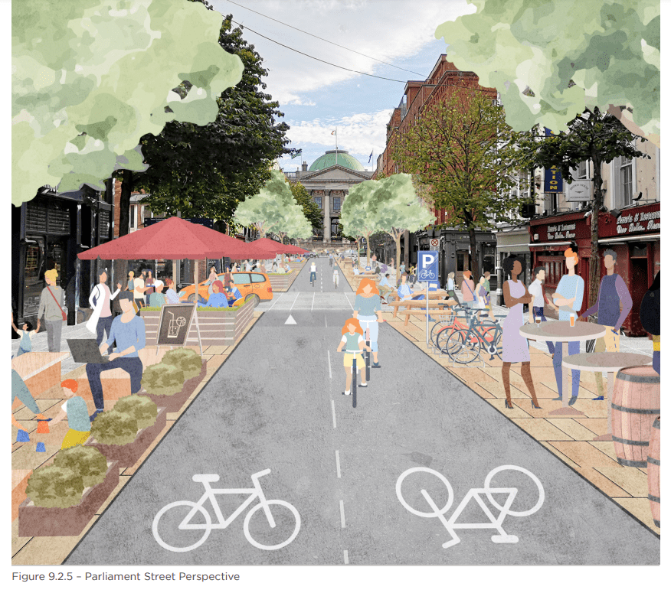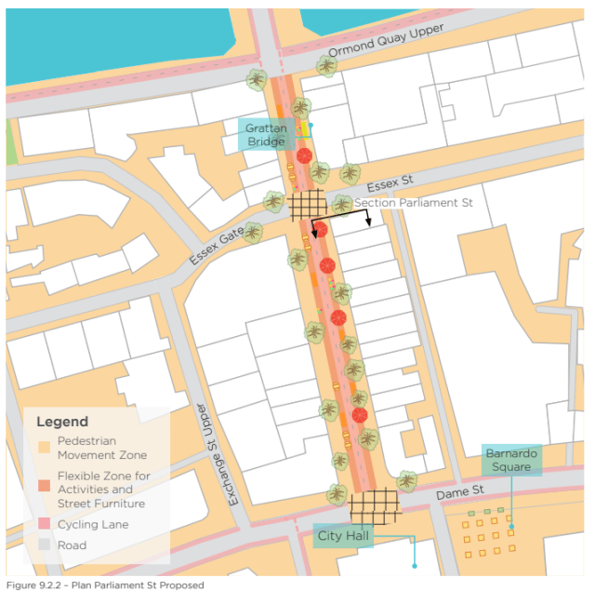

**In this area it is planned to make parliament traffic free from the quays up to Dame Street. This will have a lot of effects on everyone.**

**These are the main sections for each type of user**

1. **Disability**

**Whilst widened footpaths are in general a great idea I notice that most of the reclaimed path is taken up by outdoor dining and cycle parking.**

**It would appear the accessible parking on Essex Street is unaffected with access from Essex gate now. The existing 3 meter footpath looks clutter free and must remain so although the plan shows the new trees will be placed here so this may affect the passing of wheelchairs and buggy’s if new trees are planted without due consideration. The new buildouts for outdoor dining should be accessible to all. There is also an opportunity here to improve the pedestrian crossing points at both ends to make them more wheelchair friendly. The council needs to ensure that ad boards and dining furniture does not move onto the clear footpath.**

1. **Pedestrian**

**From a general pedestrian point of view it is welcomed but one thing that is missing from the pictures available again is public lighting which might mean the area may be unsafe in dark evenings. There is plenty of seating which is ideal for older pedestrians. At the Essex street junction there appears to be no indication for bicycles to yield to crossing pedestrians which at busy times may cause issues.**

1. **Cyclist**

**A two way cycle track is included through the centre of the area. It is a segregated track away from the footpath. Bicycle parking is provided by the outdoor eating areas but in reality 1 parking area will not be enough here.**

1. **Public transport**

**Bus connects is removing all public services from this area with buses diverted along the quays and up Winetavern street. This should not cause 2 many issues as the route using here is an infrequent service.**

1. **Deliveries**

**It has been stated that deliveries will be allowed but there is no mention of how and at what times which is important to know.**

1. **Parking/Traffic**

**There will be no changes to parking at this location as none exists. Current traffic that uses this area will be diverted via Bridge Street and high street to access Georges street and city hall/Dublin castle**

1. **Environment**

**Environmentally the area around here should improve with less traffic and new greenery been installed. The planters should also add to a clean air environment**

## 3.3 Batchelors walk

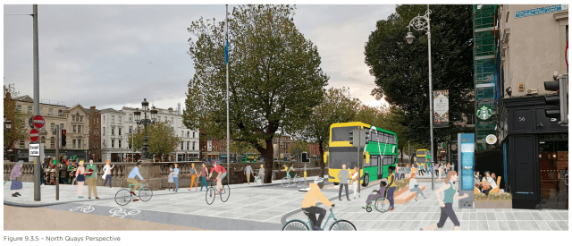 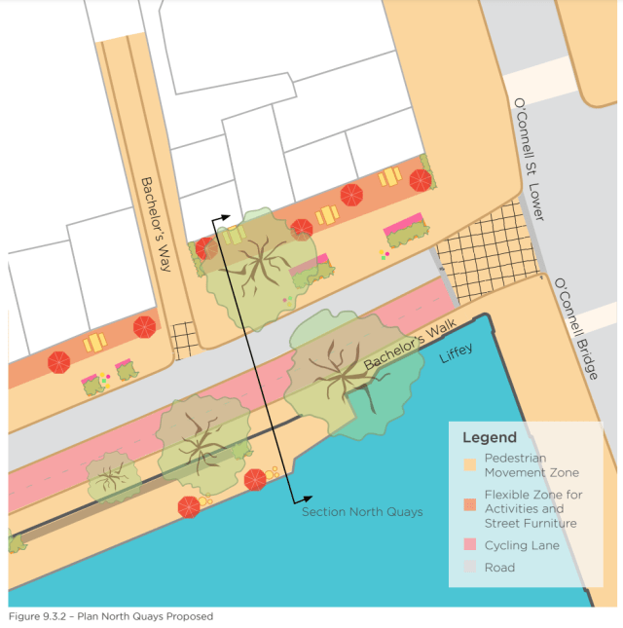

**In this area it is planned to make the area public transport and cycling only. This will have a lot of effects on everyone.**

**These are the main sections for each type of user**

1. **Disability**

**Firstly the plan shows a huge improvement in footpaths and a raised table crossing. This would mean the area would be accessible to wheelchairs but guiding strips may need to be installed for the visually impaired to navigate the wide crossing. There is no mention of nearby accessible parking for those that require it. Unlike o Connell Street there appears to be a kerb line retained to show the edge of the roadway**

1. **Pedestrian**

**From a general pedestrian point of view it is welcomed and the widened footpaths should give more capacity room. There is plenty of seating which is ideal for older pedestrians.**

1. **Cyclist**

**A two way cycle track is included along the edge of the liffey side .It is fully segregated from the footpath. There is also no indication of any bicycle parking been provided?**

1. **Public transport**

**Bus connects is adding more routes here but the bus only priority should help speed up timing issues along here. There is no indication that the light sequence will be changed so that left turning buses do not block straight ahead and right turning ones.**

**There appears to be no taxi set down or pick up points which may result in delays here.**

1. **Deliveries**

**It has been stated that deliveries will be allowed but there is no mention of how and at what times which is important to know. Also the current loading bay appears to be removed. The removal of trucks along this area may cause issues for oversized loads which cannot access the port tunnel from here.**

1. **Parking/traffic**

**There are currently no parking spaces here to lose. The closure of the quays here will result in traffic been diverted earlier mainly along Church street and Jervis street to access the port and north inner city which may impact those areas.**

1. **Environment**

**Environmentally the area should improve depending on light change times. The main worry is that trucks especially from Guinness will now have to travel via the m50 to access the port which is more environmentally damaging due to more tyre use and emission/ fuel use.**

## 3.4 South Quays

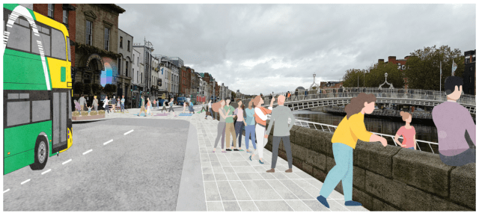 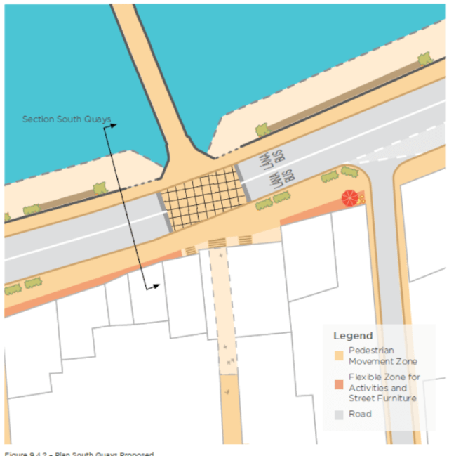 **In this area it is planned to remove traffic except buses and bicycles**

**These are the main sections for each type of user**

1. **Disability**

**The plan shows that a raised table crossing will be installed this will require edge guidance for the visually impaired. A boardwalk is proposed along here which is welcomed to increase space. The 1.7 meter wide footpath along the liffey side remains meaning this side is mostly inaccessible to wheelchairs due to current obstructions. The Ha’penny Bridge itself remains inaccessible.**

1. **Pedestrian**

**From a general pedestrian point of view it is welcomed.**

1. **Cyclist**

**No segregated cycle track is provided here meaning that cyclists must share the road with buses.**

1. **Public transport**

**Buses in general have no change here and an overtaking lane has been kept to allow the busy bus stops to pick up passengers.**

1. **Deliveries**

**Deliveries should still be possible by using the inside lane and it appears that the loading bays remain in situ.**

1. **Parking**

**It looks like traffic will not be allowed into this area so traffic normally heading west from the port and city will have to either use the north circular road or Dorset Street, Church Street which will impact on those areas.**

1. **Environment**

**Environmentally the area around the quays will have better air quality due to removed traffic. However the current traffic that uses this area is diverted into other areas and air quality will need to be measured at those areas more regularly to ensure that air pollution does not increase.**

## 3.5 Liberty place

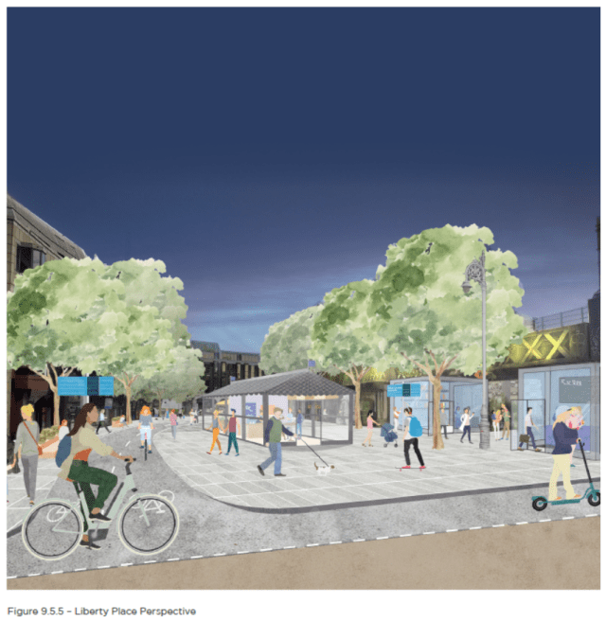 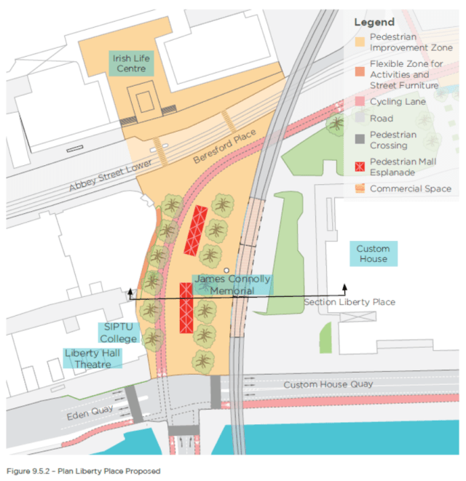 **This is a 2 part proposal either this one or the custom house gets chosen. The main reason is to create a new pedestrian area in the north inner city area.**

**These are the main sections for each type of user**

1. **Disability**

**Firstly the plan shows large open spaces that will be confusing for the visually impaired. The removal of traffic here will make crossing safer. There is no mention of nearby accessible parking for those that require it and access to public transport is also fairly distanced away from the area.**

1. **Pedestrian**

**From a general pedestrian point of view it is welcomed. There is plenty of seating which is ideal for older pedestrians.**

1. **Cyclist**

**A two way cycle track is included on the north western side .It is not clear from the pictures if this is segregated from the footpath. There is also no indication of any bicycle parking been provided?**

1. **Public transport**

**The removal of traffic here will have major issues on bus services especially for buses heading to the north side from the south side mainly routes 14 15 and 27. Coaches accessing Busarus will also be affected and buses to Ashbourne and Navan will no longer have a pick up starting point. Certain private operators also set down here.**

**Taxi access will also be removed leading to awkward rerouting and extra cost to passengers.**

1. **Deliveries**

**It has been stated that deliveries will be allowed but there is no mention of how it will be done at this location**

1. **Parking**

**With this plan there is no change to parking but access to the rear of siptu at the lane will be difficult and traffic accessing gardiner street from the south side will have to be rerouted in some way which is currently not visible due to the one way streets and no turns in the area.**

1. **Environment**

**Environmentally the area around Beresford place will have better air quality and the new trees should also help. However the current traffic that uses this area is diverted onto possibly Sherriff street and Talbot street mainly and air quality will need to be measured there more regularly to ensure that air pollution does not increase.**

## 3.6 Custom house quay

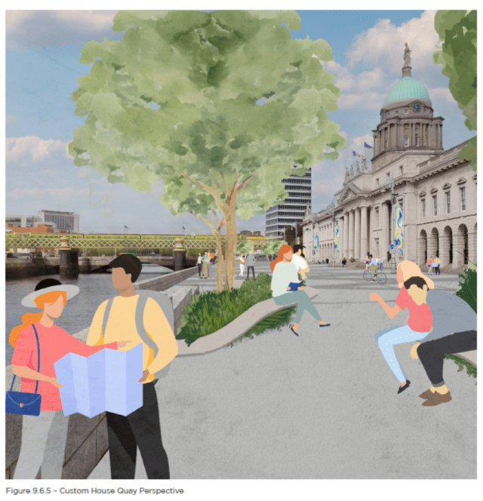 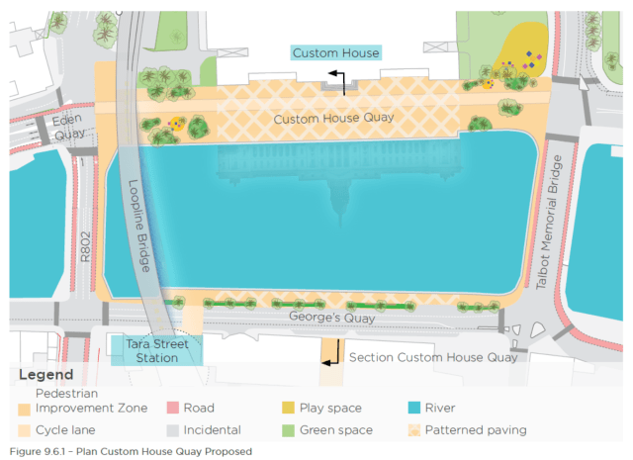

**This is the second option for this area and involves closing the area to all traffic except cyclists. In ways this is the better option**

**These are the main sections for each type of user**

1. **Disability**

**This plan allows more open spaces which will be an issue for the visually impaired. There is no mention of nearby accessible parking for those that require it and access to public transport is also fairly distanced away from the area.**

1. **Pedestrian**

**From a general pedestrian point of view it is welcomed. There is plenty of seating which is ideal for older pedestrians. The extra space will also be great for community events.**

1. **Cyclist**

**A two way cycle track is included on the northern side .It is not clear from the pictures if this is segregated from the footpath. There is also no indication of any bicycle parking been provided?**

1. **Public transport**

**The advantage of this plan is that buses and coaches that are affected can still use Beresford place and back around onto the quays so no service is really negatively impacted. Plus it does not impact on south north bus routes. The only issue is the removal of the contra flow bus lane which means that bus stops on Eden quay will have to be relocated to an already congested George’s quay**

1. **Deliveries**

**Deliveries should not be affected here as they can use Beresford place.**

1. **Parking**

**There is no parking to remove from here and traffic flow would not be adversely impacted with this design**

1. **Environment**

**Environmentally the area around the custom house will have better air quality and the new trees should also help.**

## 3.7 Gardiner street

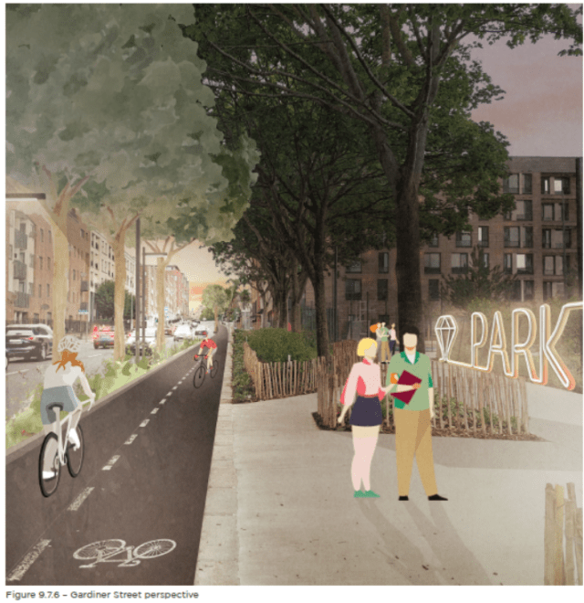 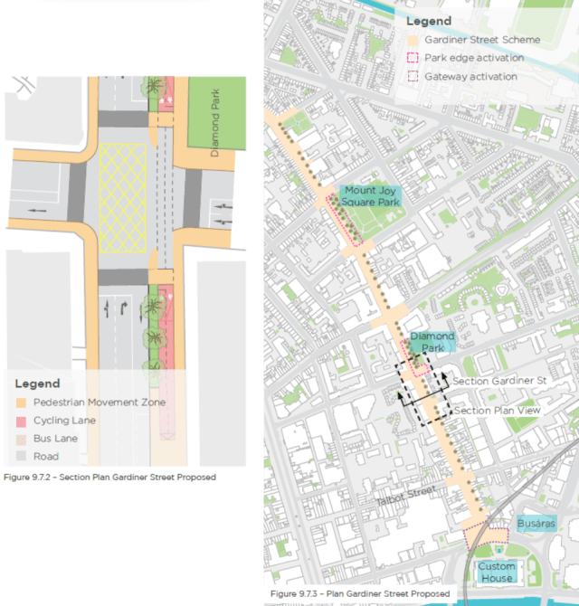 **In this area it is planned to widen the footpaths and to create a 2 way cycle track**

**These are the main sections for each type of user**

1. **Disability**

**The plan shows a slight widening of the footpaths but there appears to be street furniture placed that will cause obstructions. There is no mention of nearby accessible parking for those that require it as spaces are been removed and access to public transport is also fairly distanced away from the area. There is no mention of improvements to current pedestrian crossings either.**

1. **Pedestrian**

**From a general pedestrian point of view it is welcomed. There appears to be no new seating which is a shame as it is ideal for older pedestrians.**

1. **Cyclist**

**A two way cycle track is included on the eastern side but been only 3 meters wide it is below the acceptable standard of 4 meters. It is not clear from the pictures if this is segregated from the footpath but it is fully segregated from traffic by a green tree and flower lined partition. There is also no indication of any bicycle parking been provided?**

1. **Public transport**

**Currently only north bound buses use this road and the new bus lane will be welcomed here**

1. **Deliveries**

**Deliveries along here should not be affected although there are no dedicated loading bays.**

1. **Parking/traffic**

**It looks like all parking is been removed from the area which may affect some people. There are no changes to traffic flow except the removal of 1 south bound lane.**

1. **Environment**

**Environmentally the area will have better air quality unless south bound traffic is held up more and the new trees should also help.**

## 3.8 Pearse Street

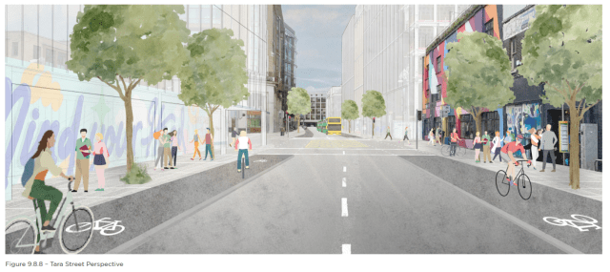 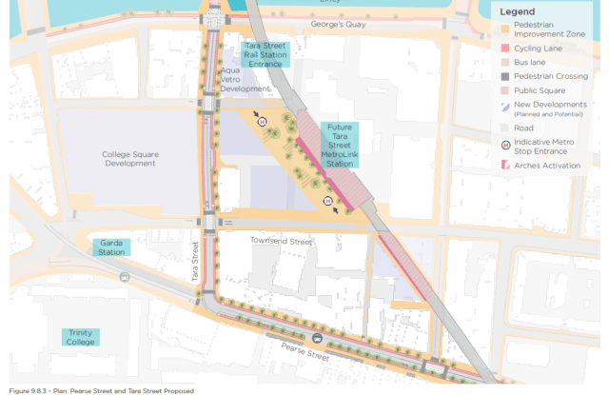 **In this area it is planned to make Pearse Street and Tara Street more cycle friendly**

**These are the main sections for each type of user**

1. **Disability**

**The plans show little change for walking routes except for slight footpath widening.it would appear that there will be new bus islands installed where they are not required if the council moved the cycle track. There is no mention of nearby accessible parking for those that require it. There is no mention of improvements to pedestrian crossing points either**

1. **Pedestrian**

**From a general pedestrian point of view it is welcomed for the footpath widening but one thing that is missing from the pictures is additional seating.**

1. **Cyclist**

**A new contra flow cycle track will be installed heading south bound on the northern side of the road. A better idea would have been to put a 2 way cycle track on the northern side as this would remove the issue of bus cycle interaction and would also align the cycle lane with the Custom house cycle track easier. There is also no indication of any bicycle parking been provided?**

1. **Public transport**

**Bus routes should not be affected but bus stops might be affected with the north bound cycle lane.**

**Taxis again have no marked out area for set down pick up.**

1. **Deliveries**

**Deliveries should not be affected too much along here as there are still 2 lanes of traffic but no loading bays**

1. **Parking/traffic**

**It looks like all parking is removed but the parking cut out at the hotel is not clear as to whether it is retained or not. Traffic lanes are been reduced but in general traffic is not too busy here. There is a proposal to ban left turning vehicles except buses from Westland row but this has not been confirmed yet.**

1. **Environment**

**Environmentally the area around here will see no major changes except for some new trees and planters**

## 3.9 Lincoln place

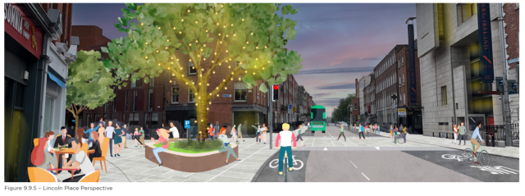 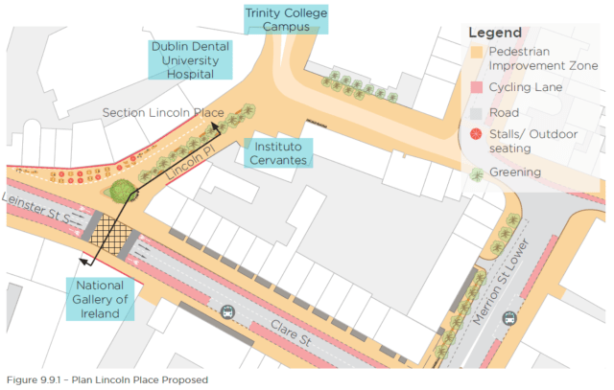 **In this area it is planned to make part of Lincoln place traffic free from Clare street up to western row. This will have a lot of effects on everyone.**

**These are the main sections for each type of user**

1. **Disability**

**The plan shows a new pedestrian plaza with a centralised tree lined boulevard with seating. Raised table crossings are been installed which will need edging on them. No nearby bus routes or accessible parking is shown.**

1. **Pedestrian**

**From a general pedestrian point of view it is welcomed especially the new plaza.There is plenty of seating which is ideal for older pedestrians.**

1. **Cyclist**

**2 one way cycle tracks are shown one is 3 meters and the other 1.5 meters .would it not have been better to install a 2 way cycle lane on the south side which would free up bus cycle interaction on the northern pathway. There is also no indication of any bicycle parking been provided?**

1. **Public transport**

**Strangely all city and northbound bus routes have been removed here with no indication of where they have gone to. A lot of routes use Lincoln place 37 38 39 145 from Leinster street and 4 7 15 26 from Merrion square along with a number of private operators. There is no other option for these routes to access Pearse Street due to the low bridges along the way unless all routes are sent down Macken Street which would involve a lot of rerouting and walking distance increases for passengers**

1. **Deliveries**

**There is no clear indication of how deliveries would access Trinity College as trucks and vans access via Lincoln place currently**

1. **Parking**

**Parking is not really affected and traffic is easily diverted along Cumberland Street heading to the city.**

1. **Environment**

**Environmentally the area around Lincoln place will have better air quality and the new trees should also help. However the current traffic that uses this area is diverted mainly and air quality will need to be measured more regularly to ensure that air pollution does not increase.**

## 3.10 Christchurch place

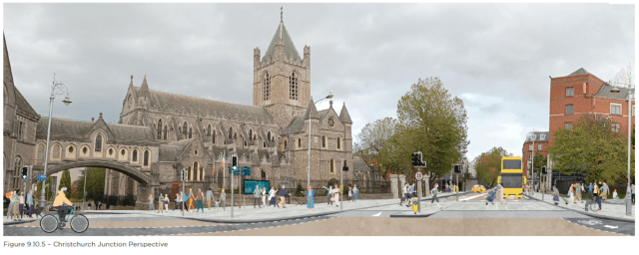 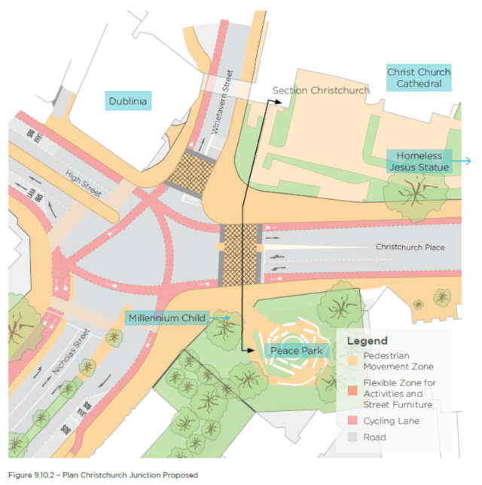 **In this area it is planned to improve the Christchurch area.**

**These are the main sections for each type of user**

1. **Disability**

**The plan states that raised crossings will be used as well as widened footpaths. There will be 2 staggered crossings at High street and Nicholas Street which is a shame as they cause issues unlike straight across crossings. There is no mention of nearby accessible parking for those that require it.**

1. **Pedestrian**

**From a general pedestrian point of view it is good with widened footpaths and more crossings. There is no seating shown unfortunately which is ideal for older pedestrians.**

1. **Cyclist**

**A network of 1 way cycle tracks is shown with a new junction layout on Nicholas Street for going straight ahead. It is not clear if any of these tracks are segregated or if advance start lights will be used. There is also no indication of any bicycle parking been provided?**

1. **Public transport**

**Bus connects will make changes to this area but from looking at the plans there are no major issues for current routes. There is one bus island shown where a cut in to the pathway would have been easier and safer as it’s a steep downhill pathway for cyclists to try slow down.**

1. **Deliveries**

**It is not clear if the loading area outside the hotel will be retained otherwise there are no changes here.**

1. **Parking/traffic**

**This area has very little parking in any case and traffic flows will possibly be changed with the closure of college green meaning less traffic going down Christchurch place city bound.**

1. **Environment**

**Environmentally the area around here won’t change much as there does not appear to be more greenery.**

# 4.0 Information and Consultation

**In looking at this area the NTA and the Council need to inform people of changes and also to liaise with cycling groups and transport companies and local residents that these changes are coming.**

**Currently most consultation is online which makes it challenging to a lot of people to see and view.**

**A lot of these changes will possibly go through under section 38 where the council does not have to consult but best practice is that it should to avoid potential conflict.**

**Proper drawings need to be shown to local residents and interest groups which show all dimensions and these should also be available in accessible formats.**

**At the moment cycling and walking is increasing in the city and also vulnerable groups like the elderly and those with disabilities are travelling more so all these designs will need to be shown to these groups in a fair and easy way.**

# 5.0 Conclusion

**Whilst all of these changes are welcome there is no universal agreement on these and here we hope to bring together a guideline which will promote best practice amongst all routes.**

**One of the biggest stigmas facing individuals with disabilities is having attention drawn to them as they are all members of society and wish to be treated as such but also at the same time they need to be listened to and to ensure best practice is always carried out.**

**I hope that the NTA and council takes note of some of the issues raised in this report and acts on them.**

**If the advice of the citizens is listened to then the NTA and city council should have no problems delivering a comprehensive cycling and pedestrian network that is beneficial to all pedestrians and cyclists alike.**

**In the diagram below it shows the timeline for implementation with proposed dates of completion in 2024 for Aston quay, Bachelors walk, Clontarf to city cycle route, Capel Street and Gardiner Street.**

**Completion in 2025 liffey cycle route, Parliament Street**

**Completion in 2026 college green, Tara Street, Pearse Street, Gardiner Street and Lincoln place**

**Completion in 2028 will be either Beresford place or Custom house quay.**

