Updates from Robert Moss (An Taisce EULIFE Green Communities Lead), Climate Action, Environment & Energy SPC Dublin City PPN Representative:

22nd February 2023 Climate Action, Environment & Energy SPC:

https://councilmeetings.dublincity.ie/ieListDocuments.aspx?CId=152&MId=4938&Ver=4

https://dublincity.public-i.tv/core/portal/webcast_interactive/750146/start_time/0

6: Re-Municipalisation of Waste Collection Services - Cllr Daithi Doolan:

Institute of Public Administration:
Research in respect of the re-municipalisation of waste services in Dublin City Council.

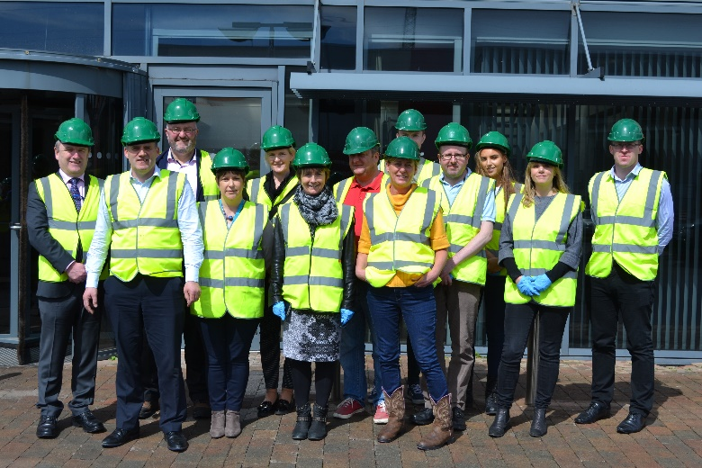

DCC SPC site visit to Thorntons Recycling, R.Moss: 2018.

A sub-committee of the Climate Change, Environment and Energy Strategic Policy Committee (SPC) was established in order to commission and oversee this research. The terms of reference drawn-up by the sub-committee indicated that the research would cover two areas:

1) To review the approach to waste collection in Dublin through a comparative analysis with the waste collection approaches pertaining in four other European cities.

2) The second phase of the research, to commence only on completion of the first phase, would consider the evidence and findings to emerge in Phase One in the context of waste management arrangements pertaining in both Dublin City and Ireland.

Three scenarios are analysed in detail:

• DCC recommencing domestic waste collection either on the basis of excluding the private operators or in competition with them

• DCC tendering for waste collection services (i.e. competition for the market)
This offers the potential for monitoring of quality control.

• Continuing with the status quo but encompassing current government policy, that is, expanding the role of the NWCPO to safeguard the interests of consumers and ensure environmental benefits.

If DCC were to look to recommence waste collection, to avoid a situation where its activities would be deemed anti-competitive it would be necessary to amend the Waste Management Act 1996 in two key respects:

• introduction of an unqualified mandatory obligation upon local authorities to collect or arrange for the collection of waste within their functional areas; and

• exclusion of other operators from the waste collection market and/or allowing for the possibility of refusing other operators access to the market if this was likely to have an adverse effect on the operation of the public waste collection service.

Contravention of competition law would be highly likely, as the conflict of interests arising due to DCC’s role as both a regulatory authority and a provider of a commercial service might easily be construed as an abuse of its dominant position in the waste collection market. In addition, the Waste Management Act would require amendment to afford local authorities the certainty they would require to recommence direct involvement with waste collection.

Issues raised at SPC Meeting:
Robert Moss noted that in the UK the local authority municipal waste collection service has not prevented litter and illegal waste dumping, which has now attracted organised crime.
The least worst option in regards to litter seems to be for the DCC tendering for waste collection services, rather than the current system of multiple operators competing in some areas and providing no service in other areas.
Until waste management companies are required to contribute toward the cost of cleaning up illegal dumping and littering within the areas where they operate and derive a profit, then the problem will continue to persist. Local Authorities have limited resources for litter management and are not able to enforce public compliance.
Dublin City Council has outsourced traffic management to private for profit companies which successfully control parking regulations. Perhaps a similar approach will need to be considered by requiring enforcement of littering and illegal dumping by waste management operators as part of a tendering agreement with local authorities.

7: Climate Action - Sabrina Dekker, Climate Action Co-Ordinator:

The focus in the next year will be on submitting our Climate City Contract to the European Commission, to be assessed and awarded the Mission Label, while aligning with our statutory obligations under the Act. To achieve this we will establish a senior management steering group to liaise with the National steering group and Cork City, review and revise our current CCAP through workshops with staff and relevant external stakeholders, develop an investment plan, and create a communications plan.
Shared Ireland Fund:
DCC is partnering with Belfast City Council on a Connected Circular Economy Project.
Dublin Climate Action Plan:
The current CAP is being revised this year and the Climate Action Plan 2024-2029 will be published in February 2024.
EU Missions: 100 Climate Neutral and Smart Cities:
Both Cork City and Dublin City are candidate cities for this EU Programme, so they will be collaborating on their Climate Action Plans together.
The application is a 12 month process which requires both a climate plan and a finance plan.

29th March 2023 Climate Action, Environment & Energy SPC:

https://councilmeetings.dublincity.ie/ieListDocuments.aspx?CId=152&MId=4964&Ver=4

5: Codling Wind Park - Pat Sammon & Fiona Campbell, Codling Wind Park:
https://councilmeetings.dublincity.ie/documents/s40748/Codling%20Wind%20Park%20Presentation.pdf
A joint 50/50% venture between Fred Olsen Seawind and EDF Renewables. Fred Olsen Renewables was involved in Codling from 1999 to 2022, when it was transferred to Fred Olsen Seawind.
The project is projected to deliver 20% of the renewable energy target of 80% that is required for 2030 (this is currently at 35% for 2021 after dropping from 42% in 2020 (Reference: Provisional greenhouse gas emissions 1990-2021 EPA Emissions Statistics team, July 2022)).
On the 27th of April 2023 their will be an auction for the future sale of electricity to Eirgrid. After this the project will go to FID for financiers to invest in.
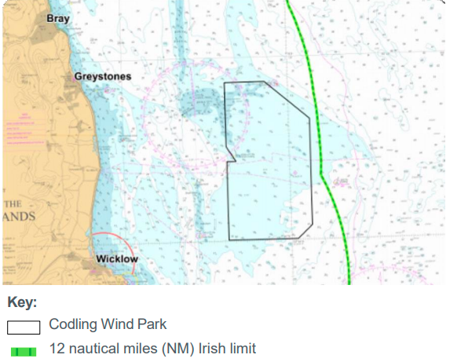
Codling site and project parameters:
• Location: 13-22km from shore between Greystones and Wicklow Town
• Site size: 125km2
• Number of turbines: up to 100
• Maximum tip height: 320m
• Maximum export capacity: 1450MW
• Operations and Maintenance base: Wicklow Port
• Grid connection location: Poolbeg, Dublin
Project contribution:
• Largest of the six Phase One projects
• One of the largest energy infrastructure investments in Ireland this decade
• Contribution: sufficient electricity to power up to 1.2 million homes
• Up to 2 million tonnes CO2 savings

Onshore grid infrastructure must connect into the existing Eirgrid transmission network. Therefore:
• Location: Poolbeg (due to existing EirGrid sub-station)
• Rationale: greatest available capacity for up to 1,450MW project
• Onshore sub-station
• Landfall site (where offshore cable comes ashore)
• Underground cable connecting landfall location to sub-station

6: Climate Action Plan 2024 - 2029 - Sabrina Dekker, Climate Action Co-Ordinator:
https://councilmeetings.dublincity.ie/documents/s40743/SPC%20Report%20-%20LACAP%20DCC%2022.3.2023.pdf
We have received the request from the Minister to develop a climate action plan (CAP). We have 12
months from February 24th, 2023 to complete the revised climate action plan. This is stated in the
Amended Act 2021.
Guidelines from DECC have been received. Guidance consists of four annexes:

1. Annex A - Developing and Implementing the Local Authority Climate Action Plan
2. Annex B – Climate Change Risk Assessment (Consultants to be engaged)
3. Annex C – Climate Mitigation Assessment: Baseline Energy Inventory (Codema to be engaged)
4. Annex D – Decarbonisation Zones (Codema to be engaged)
The CAP will need to consider National Climate Action Plan 2023, as well as sectoral adaptation
plans. The evidence base – emissions baseline and adaptation baselines – will inform the actions.
Public engagement is an important part of the CAP process.

The current Climate Action Plan themes will be changed in response to consultation.
The proposed Decarbonisation Zone themes are:
- Energy
- Biodiversity
- Transport
- Adaptation
- Just Transition

Dublin City now has two Decarbonisation Zones: Ringsend, and Ballymun.

7: Net Zero Cities - Declan McCormack, CODEMA:

https://councilmeetings.dublincity.ie/documents/s40742/NZC_SPC_presentation.pdf

Part of the Horizon Europe program it aims to support the EU’s mission 100 Climate-Neutral and Smart Cities by 2030 by helping overcome structural, institutional and cultural barriers.
The pathway is divided into a number of modules design to result in an implementation plan towards a climate neutral Dublin City by 2030:

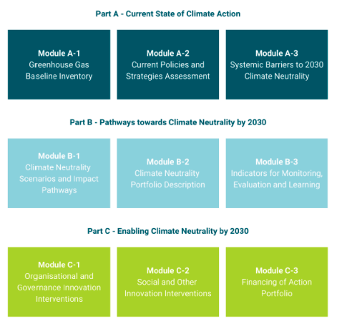
Issues raised at SPC Meeting:
Robert Moss asked what is the community engagement method for the Net Zero Cities project?
There is no prescribed template for community engagement provided by 100 Climate-Neutral and Smart Cities, but community engagement is a requirement.
Codema stated that their Zero Together Project for 2050 has a public engagement plan.

Over the next 12 months the prioritisation of these projects will be first of all the Climate Action Plan 2024-2029, followed by Net Zero Cities.
Note that the Decarbonisation Zone Strategy is now combined as an annex within the next Climate Action Plan.

8: Circular Economy Hotspot Dublin 2023 - Joanne Rourke, Eastern-Midlands Regional Waste Office:

https://councilmeetings.dublincity.ie/documents/s40741/CEHSD%20SPC%20March.pdf

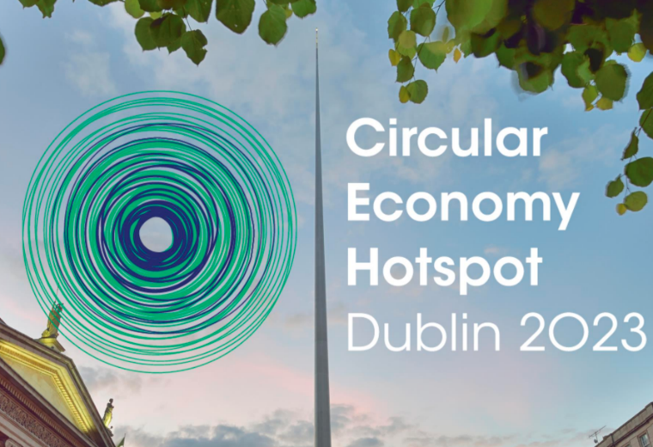

Circular Economy Hotspot Dublin is an opportunity to learn from, network with, and be inspired by the very best. Multiple events will run from the 29th of May to the 1st of June 2023. Through conference talks, tours, workshops and topic deep-dives, attendees will learn about the practical steps and resources to take home and implement. See: https://www.dublincirculareconomyhotspot.com/

