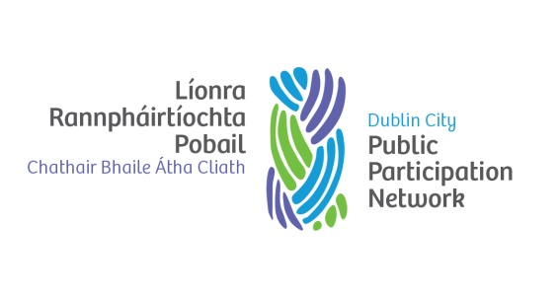
DUBLIN CITY PPN NOMINATION FORM
SOUTH CENTRAL AREA
JOINT POLICING COMMITTEE

The South Central Area Joint Policing Committee provides a forum where the local authority and senior Garda Officers responsible for the policing of that area, with the participation of Oireachtas members, Councillors and community representatives, can consult, discuss and make recommendations on matters affecting the policing of the Area.
The Committee meetings are held quarterly, on a Monday at 2.30pm in City Hall.

Name of Organisation_______________________________________________________

Select Seat Area: Ballyfermot Cherry Orchard Crumlin

Please tick PPN pillar you are registered under (if not known please leave blank):
Environment Pillar Community & Voluntary Pillar

Social Inclusion Pillar

We the undersigned
- Confirm that the nominee _______________________________________(PRINT Nominee Name) is a member of the above organisation.
- Are satisfied that this nominee meets the PPN criteria and requirements for committee representation
- Have completed the candidate form outlining how the nominee meets the requirements.
- Group is operating in the South Central area

Signed (Proposer): ___________________________________ Date: _______________

Signed(Nominee): ____________________________________ Date: _______________
Please supply contact details for the nominee:

E-mail: ___________________________________ Mobile Number: _________________
N.B Candidate Form must be completed to ensure valid nomination.
N.B. INFORMATION PROVIDED BELOW WILL BE CIRCULATED TO MEMBERS OF THE PPN

DUBLIN CITY PPN CANDIDATE FORM
SOUTH CENTRAL AREA – JOINT POLICING COMMITTEE

Candidate Name: ___________________________________________________________
Nominating Organisation: _______________________________________________
Please outline your experience and any qualities that you consider beneficial to the role of
representing the members of the PPN in the South Central Area
Please note that all information must be provided in the space below.
__________________________________________________________________________
__________________________________________________________________________
__________________________________________________________________________
__________________________________________________________________________
__________________________________________________________________________
__________________________________________________________________________
__________________________________________________________________________
__________________________________________________________________________
__________________________________________________________________________
__________________________________________________________________________
__________________________________________________________________________
__________________________________________________________________________
__________________________________________________________________________
__________________________________________________________________________
__________________________________________________________________________
__________________________________________________________________________
__________________________________________________________________________
__________________________________________________________________________
__________________________________________________________________________
__________________________________________________________________________
__________________________________________________________________________
__________________________________________________________________________
PLEASE RETURN BY WEDNESDAY 4TH OCTOBER 2017

