Updates from Robert Moss (An Taisce EULIFE Green Communities Lead), the Climate Action, Environment & Energy SPC PPN Representative:

17th of January 2023: Leaving No One Behind: Sustainable Development Goals National Stakeholder Forum:
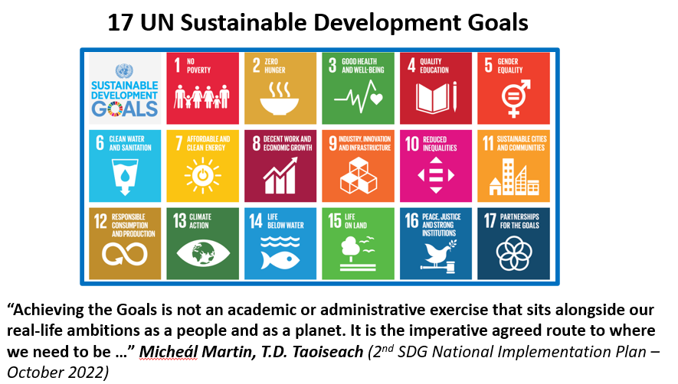

Robert Moss, the Climate Action, Environment & Energy SPC PPN Environment representative,
attended the “Leaving No One Behind: Sustainable Development Goals National Stakeholder Forum”. This followed the publication In October 2022 of Ireland’s Second National Implementation Plan for the Sustainable Development Goals 2022 – 2024:

https://www.gov.ie/en/publication/e950f-national-implementation-plan-for-the-sustainable-development-goals-2022-2024/

Five Strategic Objectives have been identified as part of this Implementation Plan to further develop SDG implementation.
Strategic Objective 3 is for “Greater partnerships for the Goals”.
Increasing collaboration will be required between local authorities, government agencies, business, and between education institutions working on climate action solutions for the delivery of policy and emission targets.

7th of February 2023: EPA Ireland Stakeholder Workshop:

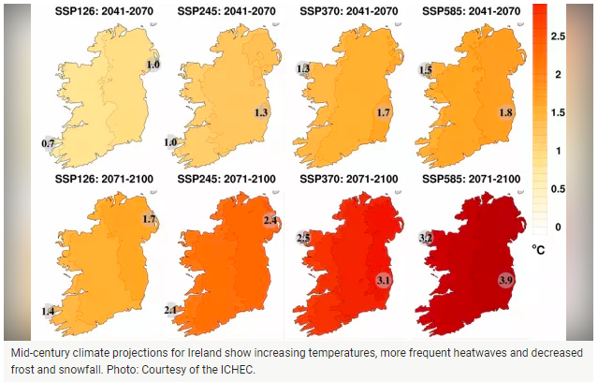

Robert Moss, the Climate Action, Environment & Energy SPC PPN Environment representative,
attended the “EPA Ireland Stakeholder Workshop” on the 7th February 2023 at the Ashling Hotel in Dublin 7.
This was to gather input for the Five Year Assessment Report on Climate Change Volume 3: Being Prepared for Ireland’s Future Climate.
The session looking at Built Environment, Heritage, and Rural Communities identified the following issues:

- Policy Misalignment
- Different timescales for different but overlapping plans
- A need for stakeholder incentives for engagement
- Finite resources
- A need for sensibility to place
- The importance of adaptation for all

Governance and policies were identified as being one of the biggest obstacles to affecting climate adaptation, with a timeline of up to 10 years to change an outdated policy!

Important Documents:
The new Dublin City Development Plan was adopted by Dublin City Council at a Special Council Meeting on 2nd November 2022 and came into effect on the 14th December 2022.
For the first time the plan contains a dedicated Climate Action chapter … available here:
https://www.dublincity.ie/residential/planning/strategic-planning/dublin-city-development-plan/development-plan-2022-2028/chapter-3-climate-action-0

The annual progress report for 2022 is available for the Dublin City Council Climate Action Plan (2019-2024).
This plan sets out 4 key targets and 219 actions that the Council will undertake in the areas of energy & buildings, transport, flood resilience, nature-based solutions and resource management:
https://councilmeetings.dublincity.ie/documents/s39286/Climate%20Action%20Plan%20Annual%20Progress%20report%202021-2022.pdf

CULTIVATE will develop the Food Sharing Compass, a social innovation support platform for Food Sharing Initiatives, policy makers, food supply actors, researchers, and citizens. The Food Sharing Compass is an online platform for multiple stakeholders to support sustainable and resilient food sharing:
https://cultivate-project.eu/

