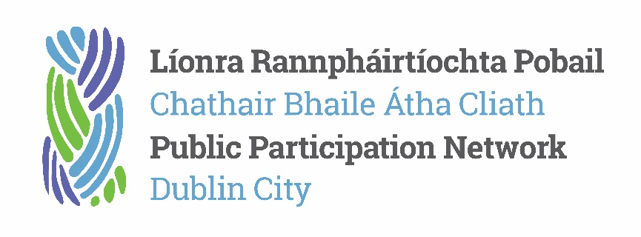
What is the Public Participation Network?
The Dublin City Public Participation Network (PPN) is a network of nearly 1000 groups and organisations working within the Dublin City area.
It is FREE to join the PPN, and member groups chose which pillar (or college) they best fit into i.e. voluntary and community/social inclusion or environmental.
The criteria for joining the PPN is very simple: groups must be not-for-profit and non-party political; they must have a constitution and be open for members of the public to join.
It is from these 1000 member groups that approximately 20 people are nominated and elected to sit on local authority Strategic Policy Committees (SPCs) in the areas of housing/transport/planning/culture/climate/economic development and finance. There are also seats for PPN Representatives on the Joint Policing Committee (JPC) and the Local Community Development Committee (LCDC).
A Secretariat of 9 people steer the PPN (3 elected people from the 3 pillars), and two members of staff administer the work.
The next local elections will be held on 06 June, after which the SPCs will be dissolved and reconvened. This means, that the Dublin City PPN will have approximately 20 open vacancies for seats on a variety of diverse committees.
If you are interested in being a PPN representative on one of the following SPCS; housing/transport/planning/culture/climate/economic development or finance and we would like to hear from you. We are collecting a list of names of people who would like to represent the PPN on these local authority committees, and feel that they have the skills, experience, aptitude and nature to represent the PPN in the best way that they can.
We will also be looking to fill 2 LCDC seats, 1 Secretariat seat and 1 JPC seat.
A person must be nominated by a member group of the PPN and seconded. If only one person is nominated for the seat, that person will be deemed to be elected. If more than one person is nominated, we will hold an online election using the software, Election Buddy. The primary contacts from member groups are sent an online vote. Every college (or pillar i.e. voluntary and community or social inclusion, or environment) votes for the representatives from that college. Meanwhile, the primary contact, from each member group, will ask other people from their member group who they would like to vote for.
The ideal candidate will have experience of committee work, representative work, will have a genuine interest in one of the issues and will be able to feedback information to the network, and take onboard feedback from the network to present at committee.
- Challenges of the representative role: committee work is slow, being a representative involves compromise, it can be quite isolating, the SPC system itself is quite new and clunky.

- Opportunities of the representative role: a literal seat at the table with Dublin City Council, the chance to network with 1000 groups, the time to think deeply and profoundly about issues facing the city.
Email Ruth or Rachel for further information about the network, the member groups and the events/training programmes we have on offer in 2024.

Further information
Social media channels X and Facebook @dublincityppn
PPN Handbook – PPN Handbook (2020) - Dublin City Public Participation Network (dublincityppn.ie)
Dublin City PPN workplan for 2024 - Draft Workplan and Budget 2024 - Dublin City Public Participation Network (dublincityppn.ie)
Watch the SPC meetings online: Home - Dublin City Council Webcasting (public-i.tv)
PPN Training
Social Justice Ireland: Social Justice Ireland have an online, self-guided course on the Public Participation Networks. This online support covers the following topics: an introduction to PPNs, effective facilitation, effective participation in consultancies, local government budgets, measuring outcomes and impacts, PPNs and local government and strategic planning. You can register for this support here.
The Wheel: The Wheel provide online supports to the Public Participation Networks and topics include: PPN Hosting Arrangements, Basics of Employment and HR Practice, Successful Communication for Community Groups and Voluntary Boards, Leading Communities: the Role of Board or Committee Members, Social Media, Procurement, Strategic Planning. You can download these resources here.

